Motor Accident Report Form EMAIL: claims@powellcommercial.com

POLICYHOLDER’S NAME POLICY NUMBER:

V.A.T Registered? YES ☐ NO ☐
DRIVER OF POLICYHOLDER’S VEHICLE (OR LAST IN CHARGE)
Name: Date of Birth:

Address: Date Test Passed:

Contact Number: Class of License Held:

Occupation: Vehicle being used with Policyholder’s permission? YES ☐ NO ☐ Agency Driver? YES ☐ NO ☐

Have you had any accident, loss (incl. fire or theft) or claim in the last 5 years? YES ☐ NO ☐ If yes, give details:

Give details of all motoring convictions or prosecutions pending: YES ☐ NO ☐ If yes, give details:

Give details of any physical defect, infirmity, defective vision or hearing. YES ☐ NO ☐ If yes, give details:

POLICYHOLDER’S VEHICLE
Reg No: Make: Model: Gross Vehicle Weight:

For what purpose was the vehicle being used:

Is the vehicle owned by you or registered in the company’s name?:

Is the vehicle subject to hire purchase or vehicle leasing agreement? YES ☐ NO ☐ If yes give details:

Number of passengers:

Trailer Attached? YES ☐ NO ☐ Make/Model/Serial Number:

Vehicle still in use? YES ☐ NO ☐ Damage to vehicle / Point of impact:

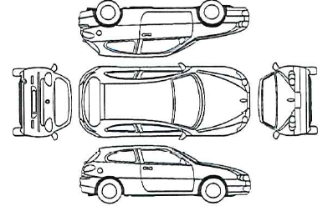

Do you have photos of the damage? YES ☐ NO ☐ (If yes please attach)

Where is the vehicle now? Location:

Contact Number:

INCIDENT DETAILS
Date of Incident: Time of Incident: Speed of Vehicles: Yours (mph): Others (mph):

Location of Incident:

CIRCUMSTANCES OF INCIDENT
Please confirm exactly how the incident happened and confirm details of all property damage.

IS THE INSURED DRIVER FULLY TO BLAME FOR THIS INCIDENT?
YES ☐ NO ☐ If “No” why not?

OTHER PARTY INVOLVED
Name: Reg No:

Address:

Make:

Model:

Contact Number: Number of Passengers:
Damage to vehicle / Point of impact:

Do you have photos of the damage? YES ☐ NO ☐ (If yes please attach)

Insurers: Policy No:
PROPERTY DAMAGE (other than vehicle)
Name & Address of Owner: | Extent of Damage:

